Vertical Distances - Levelling

Measuring the height

Measuring and calculating the height of a point relative to another point

Level Spirit level Water level Optical level

The figures below show how to focus an optical level

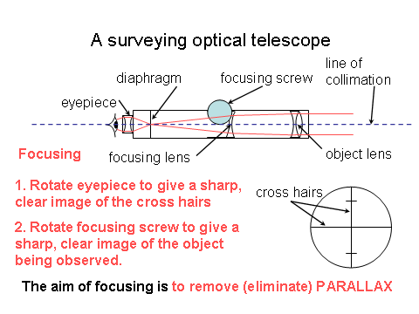
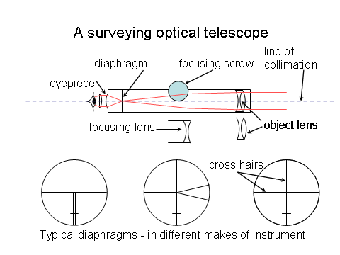

When pond bubble is centred the instrument’s standing axis is approximately vertical.
The compensators in the instrument take over and adjust the optical Line of Collimation so that it is horizontal (hopefully)
When the instrument is rotated the compensators ensure that a horizontal plane of collimation is swept out (hopefully)

Parallax.

When focussing any optical instrument it is vitally important that we eliminate Parallax.
Move the eye up and down (or from left to right) over the eyepiece of the telescope.
If the cross hairs move relative to the object being observed then Parallax exists and the focussing is not satisfactory.

Elimination of Parallax

Focus the crosshairs
(using the Eyepiece)
Focus the object
(using the Focussing screw)
Images appear
to move
Parallax exists and
must be removed by
better focussing

Parallax has
been removed
Therefore focussing
is good

Height of Plane of Collimation (HPC)
The height of the central reticle of a level. It is given by taking a known or assumed benchmark, placing a staff on it, reading the staff, and adding the resulting reading to the benchmark value. Sighting from here to a staff held on any other point can give the height of the new point, by subtracting the new staff reading from the HPC.
